PIZZA SALES SQL QUERIES
1.KPIs
1.Total Revenue
select sum(total_price) as Total_Revenue from pizza_sales;

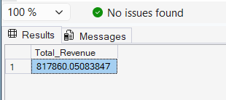

2.Average Order Value
select sum(total_price)/count(distinct order_id) as Average_Order_Value from pizza_sales;

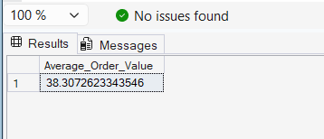

3.Total Pizza Sold
select sum(quantity) as Total_Pizza_Sold from pizza_sales;
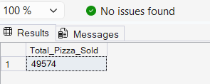
By category

select pizza_category,count(quantity) from pizza_sales
group by pizza_category

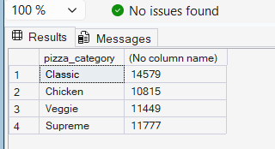

4.Total Orders
select count(distinct order_id) as Total_Orders from pizza_sales

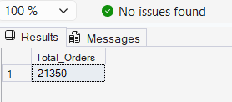
5.Average pizza per order
select cast(cast(sum(quantity) as decimal(10,2))/
(count(distinct order_id) as decimal(10,2))as decimal(10,2)) as Avg_pizza_per_Order
from pizza_sales

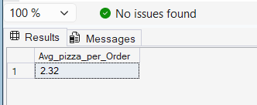

2.Charts
1.Daily-Trend
select DATENAME(dw,order_date) as order_day,count(distinct order_id) as total_by_day
from pizza_sales group by DATENAME(dw,order_date)
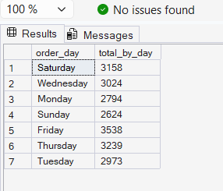
2.Hourly Trend
select DATEPART(HOUR,order_time) as order_time,count(distinct order_id) as total_by_day
from pizza_sales
group by DATEPART(HOUR,order_time)
order by DATEPART(HOUR,order_time)

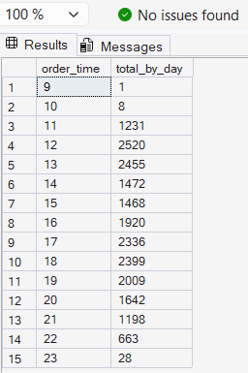
3.Percentage of Total
select pizza_category,sum(total_price)* 100/ (select sum(total_price) from pizza_sales) as PCT from pizza_sales group by pizza_category
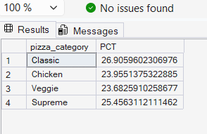

4.sales by Price
select pizza_size,cast(sum(total_price)* 100/ (select sum(total_price) from pizza_sales)as decimal(10,2)) as PCT from pizza_sales group by pizza_size

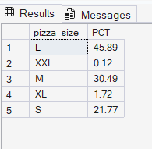
5.Top 5 pizza sold

SELECT TOP 5 pizza_name, SUM(quantity) AS Topsale FROM pizza_sales GROUP BY pizza_name
ORDER BY Topsales DESC;

